Preparation of Schottky Diodes Based on Copper Electrode and Polyaniline–Cadmium Oxide Composites

Nadeem Anwar(http://orcid.org/0000-0003-2815-3714)^{a,} * , Abdul Shakoor(http://orcid.org/0000-7890-2815-3714)ª , Waheed Qamar(http://orcid.org/0000-0002-8210-5257)^{b} , Niaz Ahmad Niaz(http://orcid.org/0000-0003-0628-8802)^{a, b} , Muhammad Qasim(http://orcid.org/0000-0003-2629-3350)ª , and Muhammad Irfan(http://orcid.org/0000-0003-1387-6784)ª

ªDepartment of Physics, Bahauddin Zakariya University Multan, Box. 60800 Pakistan
^{b}Institute of Advanced Materials, Bahauddin Zakariya University Multan, Pakistan
*e-mail: nadeemgccl82@gmail.com

Abstract—In situ chemical polymerization technique was used to synthesize polyaniline (PANI) and polyaniline–cadmium oxide (PANI/CdO) composites with different contents of CdO. The structure and morphology of pure and synthesized nanocomposites were characterized by XRD and SEM. Different weight concentrations of CdO was used to examine their effects on these characteristics. The XRD data suggest a better crystallinity and show more intense peaks of PANI/CdO composites with added CdO nanoparticles. The SEM images of PANI/CdO show intercalary, agglomerated platelet as well as flaky structures. Current density–voltage (J–V) characteristics of ITO/PANI/Cu, ITO/PANI-CdO composites/Cu, and prepared Schottky diodes were studied at room and higher temperatures in the potential window of 20 V. The junction parameters such as the saturation current, ideality factor, and barrier height were calculated and found to be influenced by the concentration of CdO and temperature. The electrical behavior of PANI with CdO was found to agree with the thermionic emission model for the Schottky-barrier-type devices.

INTRODUCTION
Organic semiconducting polymers have received considerable attention due to their unique electrical, chemical, physical, and optical properties and have been considered for applications in advanced microelectronic and optoelectronic devices [1]. These polymers include polyaniline [2], polypyrene [3], polyacetylene, and other conjugated polymers [4]. Polyaniline (PANI) is the most promising conjugated polymer due to its modifying electrical conductivity [5]. <…>
Transition metal oxides (TMO) have become a widespread type of inorganic semiconducting compounds with various structures and properties [11, 12] and have wide range of applications [13]. Compared with other semiconductor nanoparticles, cadmium oxide nanoparticles have a low toxicity [14, 15]. Currently, many multivitamin pills and dietary supplements contain cadmium [16, 17]. Cadmium oxide belongs to n-type (II–IV) semiconducting compound with a band gap of 2.5 eV and exciton binding energy of about 75 (meV) [18, 19]. It has high transmission in visible region and high conductivity [20]. The electrical resistivity is of the order of 10^{–2}‒10^{–4} Ω cm [21, 22] and mobility as high as μ = 146 cm² V^{–1} s^{–1} with N = 1.5 × 10²⁰ cm^{–3} [23, 24]. Moreover, it can be used as transparent electrodes of solar cells [25, 26]. The reason behind the use of CdO nanoparticles in electronic devices is its semiconducting and piezoelectric characteristics [27].
The conjugated polymer/inorganic nanoparticles composites have unique physical properties and attracted much attention. As they combine the merits of conducting polymers and inorganic nanoparticles [28]. Three kinds of contacts can be made:
- Ohmic contact, which allows flow of free charges from polymer to contact (metal) and vice versa.
- Rectifying contact, which allows only unidirectional flow of charges.
- Blocking contact, allowing no injection or extraction of charges from the polymer.
<…>
In this work, because cadmium oxide is toxic, a small amount of cadmium oxide is used as an additive. Metallic copper is used as a rectifying contact for the first time with CdO-doped PANI to prepare Schottky diodes and various junction parameters have been investigated by the J–V characteristics.

EXPERIMENTAL
Material
Aniline was purchased from Raidel-de-Haen. Cadmium oxide was purchased from UNI-CHEM. Ammonium persulfate (APS) was provided by DUKSAN and hydrochloric acid (HCl) was provided by Sacharlu. All the materials were used as received, without any further purification.

Synthesis of Polyaniline (PANI) and Polyaniline/CdO Composites
Polyaniline was synthesized in an open atmosphere using in situ chemical polymerization method in the presence of HCl as a catalyst and APS as an oxidant, polyaniline shows synthetic behavior in an open atmosphere. <…>
Polyaniline/nanocomposites with (0.5, 1.5, 2.5) weight concentrations of CdO dopant were also synthesized by in situ chemical polymerization method. Aniline (5 mL) was added to 100 mL of distilled water. Then, 5 mL of HCl was added dropwise to the solution, and the mixture was stirred for 3 h. Further steps were the same as in the synthesis of polyaniline.

Preparation of Schottky Diodes
Paste of PANI and PANI/CdO composites were dried in a vacuum oven at 70°C for 24 h, and the films of the above materials were prepared by the spin coating method on a glass coated by indium–tin oxide (ITO) as shown below: <…>

Measurements
X-ray diffraction analysis was carried out using a Bruker XRD model D8 ADVANCE (CuK_{α} radiation, λ = 1.5406 Å). The instrument operated at 40 kV and 30 mA. The synthesized samples were mounted on a standard holder and diffraction patterns were recorded at 10°–80° at a scan rate of 2°/min. Scanning electron microscopy was performed using a MAIA3 TESCAN instrument having ×10000 magnification. Two probe technique was used to characterize the prepared Schottky diodes ITO/PANI/Cu and ITO/PANI/CdO/Cu by the measurements of current density vs. voltage (J–V) characteristics at room and some elevated temperatures. The J–V measurements were carried out with the aid of a Keithley 2400 electrometer. The specimen was mounted onto the sample holder with the copper side connected to positive and the ITO side connected to the negative ends of the power supply. The temperature was controlled by a cryostat and measured by a digital bimetallic thermometer.

RESULTS AND DISCUSSION
XRD Analysis
The structure of pure PANI, PANI/0.5%CdO, PANI/1.5%CdO, PANI/2.5%CdO and pristine CdO were characterized by XRD. Pure PANI are X-ray amorphous [31]. Only a broad peak is observed at 2θ = 15°‒20°. JCPDS file no. 05-0640 was used to index the XRD spectra of pristine CdO and synthesized samples. The XRD spectra of CdO and synthesized samples show reflections from the (200), (210) and (311) planes. The most pronounced reflections are from the (200), (210) planes and the least, from the (311) plane. This indicates the presence of CdO in PANI as shown in Fig. 1. The crystallite size was calculated by the Debye–Sherrer’s formula [32] for the (200), (210), and (311) planes as shown in Table 1:

D = 0.9λ/βcosθ.

A small increase in the concentration of CdO in the PANI matrix, significantly changes the crystallite size and influences the preferential growth direction.
<…>

SEM
To study the interaction between PANI and CdO nanoparticles (with different weight concentrations), SEM images were obtained as shown in Fig. 2. The SEM image of CdO shows porous and agglomerated morphology of small spherical, spindle, dumbbell, and cuboidal shaped particle crystallites [36]. <…>

PANI and PANI/CdO Composites Schottky Electrodes
In this work, both pure and doped polyaniline composites with different weight concentrations of CdO were synthesized by in situ chemical polymerization. The current density–voltage (J–V) characteristics of ITO/PANI/Cu and ITO/PANI-CdO composites/Cu prepared Schottky diodes were investigated at room and higher temperatures (Figs. 3 and 4).
<...>
The nonlinear J–V characteristics of the metal/polymer junction could be presumed due to a mechanism of thermionic emission, the contribution of Child’s law, tunneling current, diffusion and space charge limited current (SCLC) as well as Schottky emission current [39]. The Child’s law is given by the equation

eJ = AV ², (1)

where A is a proportionality constant.
<…>
The possibility of bulk limited Poole–Frenkel emission [40] was not observed, because the plot of ln(J/V) vs. V ^{0.5} is not a straight line (Fig. 7).
In our experiments, J–V curves are nonlinear, asymmetrical, and have exponential dependence of electrical current density on bias voltage. The thermionic emission can be assumed a dominant carrier transport mechanism, supposing no diffusion and no tunneling taking place [41]. According to this model, J–V relationship is given by the equation

J = J_{o} exp(eV/nkT ‒ 1), (2)

where J_{o} is the saturation current density, V is the applied voltage, k is the Boltzmann constant, and n is the diode ideality factor. At room temperature, eV >> nkT, and Eq. (2) can be rewritten as

J = J_{o} exp(eV/nkT), (3)

J_{o} has been calculated from the intercept of the plots, and the values of ideality factor n were calculated by the equation

d[logJ]/dV = e/nkT. (4)

The barrier height φ can be obtained from the Richardson equation:

J_{o} = A*T ²exp(‒eφ/kT), (5)

where A* is effective Richardson constant taken equal to 120 A cm^{–2} K^{–2}, for free electron and is usually assumed to be a Schottky diode and a p-type organic semiconductor in the calculation of barrier height φ [42]. By using these equations, the junction parameters J_{o}, n, and φ for ITO/PANI/Cu, ITO/PANI/0.5%CdO/Cu, ITO/PANI/1.5%CdO/Cu, ITO/PANI/2.5%CdO/Cu were calculated at different temperatures as shown in Table 2.

CONCLUSIONS
<…> The saturation current density increases, and the barrier height decreases with increasing concentration of CdO in PANI matrix. The electrical behavior of PANI with CdO was found to be in good agreement with the thermionic emission model for the Schottky-barrier-type devices.

CONFLICT OF INTEREST
The authors declare that they have no conflicts of interest.

REFERENCES
1. A. Hajibadali, M. Baghaei Nejad and G. Farzi, Braz. J. Phys. 45, 394 (2015). https://doi.org/10.1007/s13538-015-0334-y
2. A. M. Farag, A. Ashery, and M. Abdel Rafea, Synth. Met. 160, 156 (2010). https://doi.org/10.1016/j.synthmet.2009.10.024
3. A. A. Khan and L. Paquiza, Synth. Met. 161, 899 (2011). https://doi.org/10.1016/j.desal.2010.07.058
4. A. Budkowski, A. Bernasik, E. Moons, M. Lekka, J. Zemla, J. Jaczewska, J. Haberko, J. Raczkowska, J. Rysz, and K. Awsiuk, Acta Phys. Pol., A 115, 435 (2009). http://doi.org/10.12693/APhysPolA.115.435
5. Conjugate Polymers, Ed. by J. L. Bredas and R. Silbey (Kluwer Academic, London, 1991).
<…>
40. E. H. Rhoderick and R. H. William, Metal Semiconductor Contacts, 2nd ed. (Clarendon, Oxford, 1998).
<…>

TABLES
Table 1. Characteristics of the samples: hkl, 2θ, d_{hkl}, D, and crystallinity of pure PANI, PANI/0.5%CdO, PANI/1.5%CdO, PANI/2.5%CdO, and pristine CdO

Sample | hkl | 2θ, deg | Calculated d_{hkl}, Å | D, nm | Crystallinity, %
Pure PANI |  | 17.4 |  | 0.42 | 49.5
PANI/0.5%CdO | 200  210  311 | 40.08  46.61  68.36 | 2.25  1.95  1.37 | 1.4  1.5  1.6 | 56.5
PANI/1.5%CdO | 200  210  311 | 40.01  46.60  68.28 | 2.25  1.95  1.37 | 1.7  1.8  2.0 | 76.9
PANI/2.5%CdO | 200  210  311 | 40.28  46.83  68.28 | 2.24  1.94  1.37 | 1.7  1.8  2.0 | 88.7
Pristine CdO | 200  210  311 | 40.16  46.75  68.28 | 2.24  1.94  1.37 | 12.5  12.8  14.2 | 99.1

<…>

FIGURE CAPTIONS
Fig. 1. XRD patterns of (1) pure PANI, (2) PANI/0.5%CdO, (3) PANI/1.5%CdO, (4) PANI/2.5%CdO, (5) pristine CdO respectively.

Fig. 2. SEM images of (a) pristine CdO, (b) pure PANI, (c) PANI/0.5%CdO, (d) PANI/1.5%CdO and (e) PANI/2.5%CdO respectively.

Fig. 3. A plot of J vs. V for (1) ITO/PANI/Cu, (2) ITO/PANI/0.5%CdO/Cu, (3) ITO/PANI/1.5%CdO/Cu, (4) ITO/PANI/2.5%CdO/Cu Schottky diodes at room temperature.

Fig. 4. A plot of J vs. V for (a) ITO/PANI/Cu, (b) ITO/PANI/0.5%CdO/Cu, (c) ITO/PANI/1.5%CdO/Cu, (d) ITO/PANI/2.5%CdO/Cu Schottky diodes at different temperatures: (1) 30, (2) 60, (3) 90, (4) 120, (5) 150, and (6) 180°C.

Fig. 5. A plot of J vs. V ² for (1) ITO/PANI/Cu, (2) ITO/PANI/0.5%CdO/Cu, (3) ITO/PANI/1.5%CdO/Cu, (4) ITO/PANI/2.5%CdO/Cu Schottky diodes at room temperature.

Fig. 6. A plot of log J vs. V for (1) ITO/PANI/Cu, (2) ITO/PANI-0.5%CdO/Cu, (3) ITO/PANI/1.5%CdO/Cu, (4) ITO/PANI/2.5%CdO/Cu Schottky diodes at room temperature.

Fig. 7. A plot of log(J/V) vs. V ^{0.5} for (1) ITO/PANI/Cu, (2) ITO/PANI/0.5%CdO/Cu, (3) ITO/PANI/1.5%CdO/Cu, (4) ITO/PANI/2.5%CdO/Cu Schottky diodes at room temperatures.

<…>
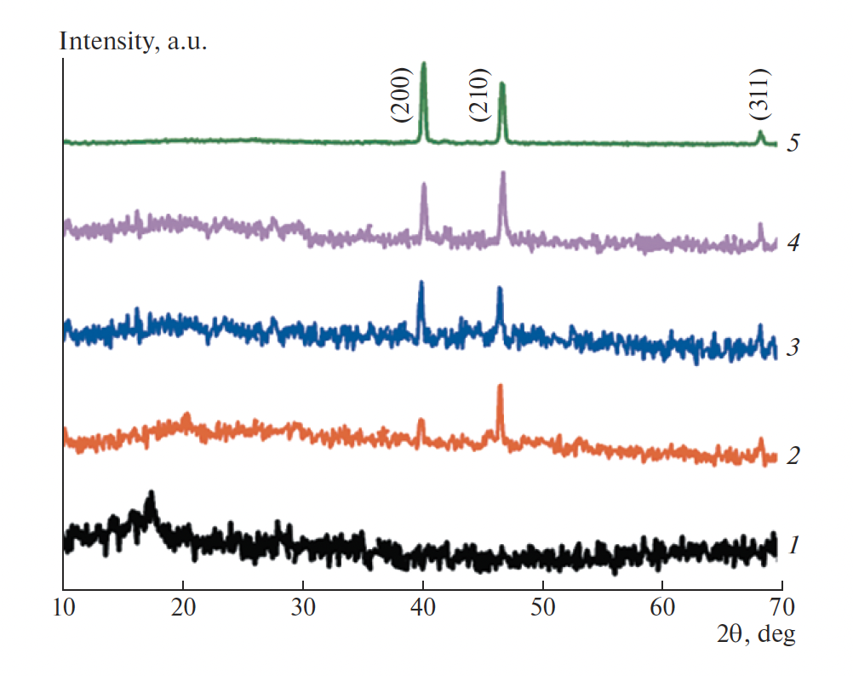
Fig. 1.
<…>

